**虛擬辦公室服務及公司秘書服務計畫申請表  
Virtual Office Service And Company Secretary Service Application Form**

客戶盡職審查  
Customer due diligence  
(本公司職員填寫)  
(Stuff use only)

**注意：必須填寫此申請表內所有空格 (不適用者請以“N/A”表示)** **Caution: All boxes on this application form must be filled out (if not applicable, put “N/A”)**

請在適當的方格內填上(✓)號或(x)號以表示你的選擇　Please check (✓) or cross (x) the appropriate box to indicate your preference

|  |  |  |  |  |  |
| --- | --- | --- | --- | --- | --- |
| **申請人資料 Applicant Information** | | | | | |
| 公司名稱 Company Name  *如以個人名義申請，則填上申請人的中英文姓名(全寫)*  *For Personal Applicant, please enter FULL NAME in English & Chinese* | 英文名稱 English Name | Click Here to Enter Text | | | |
|
| 中文名稱 Chinese Name | Click Here to Enter Text | | | |
|
| 公司種類 Type of Company | 私人股份有限公司 Private Company Limited by Shares　  個人名義 Personal  獨資 Individual　  合夥 Partnership　  其他 Others:　 Enter Here | | | | |
| 公司註冊地址 Company’s Registered Office | Shop/Room, Floor, Commercial/Industrial Building  Street No.  Complex/Community, District  (需要更改公司註冊地址服務的客人必須提供現有註冊地址)  (Client(s) who need our service to change R/O service must provide the company's) | | | | |
| 商業登記號碼 Business Registration No. | Enter Here | | 公司資產 Assets of Business | 低於30萬港幣 Below 300k HKD | |
| 公司成立日  Date of Incorporation | Select Date | | 高於30萬港幣 More than 300k HKD | |
| 高於1000萬港幣 More than 100m HKD  請另外填寫資金來源申報表 | |
| 公司註冊編號  Companies Registry No. | Click Here to Enter No. | | | 公司交易地區 Location of Business Activities | 本地 |
| 業務性質  Business Nature | Click Here to Enter Text | | | 海外  請註明Indicate: Enter Here |
| 資金來源 Source of Funds | 實益擁有人個人資產Beneficiary owner(s) personal assets  集團內部融資 Intra-Group Financing  其他 Others:　 Enter Here | | | | |
| *需提供注入公司的資金來源證明文件　Please provide us with the supporting documents of the source of funds to be injected into the Company* | | | | |

|  |  |  |  |  |  |  |  |  |  |
| --- | --- | --- | --- | --- | --- | --- | --- | --- | --- |
| **公司人員資料**  **Company Member Information** | | | | | | **不現身**  **No Show** | | **加入創業者同盟**  **Join Membership** | |
| 申請人身份 Applicant’s Position | 重要控制人Significant Controllers  股東Shareholder  東主Sole Proprietor  重要控制人 Significant Controllers | | 指定代表  Designated Representative  董事Director  合夥人Partner | | | | 公司秘書Company Secretary  公司職員Staff  其他Other 請註明  PleaseSpecify: _______________ | | |
|  | | | | | | |
| *唯一董事不能兼任公司秘書　A sole director cannot be the Company Secretary* | | | | | | | | |
| 英文姓名 Full Name in English | Enter Here (E.g.: CHAN Tai Man/CHEN Dawen) | | | | | 持股量  Number of Shares | | | Enter Here (只適用於股東)  (Shareholder only) |
| 中文姓名 Full Name in Chinese | Click Here to Enter Text | 性別 Gender | | Select | |
| 身份證/護照號碼 I.D. / Passport No. | Click Here to Enter Text | 簽發國家 Issuing Country | | | | Click Here to Enter Text | | | |
| 聯絡電話 Contact Number | Click Here to Enter Text  **WhatsApp** | 其它國籍 (如適用)  Other Nationality  (If Applicable) | | | | Click Here to Enter Text | | | |
| 住址/聯絡地址 Residential / Correspondence Address  (董事必須提供住址　Director must provide residential address) | Flat/Room, Floor, Block, Building  Street No.  Complex/Community, District  Country | | | | | 即時通訊軟體Instant Messenger | | | Select |
| 用戶名/號碼  AC Name / No. | | | Enter Here |
| 電郵地址 E-mail | Click Here to Enter Text | | | | | | | | |
| 資金來源 Source of Funds | 商業 Business  薪金 Salary | | | | 繼承或餽贈 Inheritance/Gift  其他 Others:　 Enter Here | | | | |
| *需提供注入公司的資金來源證明文件　Please provide us with the supporting documents of the source of funds to be injected into the Company* | | | | | | | | |
| **若申請人多於兩位，每增加一位申請人之附加費用為HKD100。　An additional of HKD100/person will be charged if there are more than 2 applicants.** | | | | | | | | | |
| **公司人員資料**  **Company Member Information** | | | | | | **不現身**  **No Show** | | **加入創業者同盟**  **Join Membership** | |
| 申請人身份 Applicant’s Position | 重要控制人Significant Controllers  股東Shareholder  東主Sole Proprietor  重要控制人 Significant Controllers | | 指定代表  Designated Representative  董事Director  合夥人Partner | | | | 公司秘書Company Secretary  公司職員Staff  其他Other 請註明  PleaseSpecify: _______________ | | |
|  | | | | | | |
| *唯一董事不能兼任公司秘書　A sole director cannot be the Company Secretary* | | | | | | | | |
| 英文姓名 Full Name in English | Enter Here (E.g.: CHAN Tai Man/CHEN Dawen) | | | | | 持股量  Number of Shares | | | Enter Here (只適用於股東)  (Shareholder only) |
| 中文姓名 Full Name in Chinese | Click Here to Enter Text | 性別 Gender | | Select | |
| 身份證/護照號碼 I.D. / Passport No. | Click Here to Enter Text | 簽發國家 Issuing Country | | | | Click Here to Enter Text | | | |
| 聯絡電話 Contact Number | Click Here to Enter Text  **WhatsApp** | 其它國籍 (如適用)  Other Nationality  (If Applicable) | | | | Click Here to Enter Text | | | |
| 住址/聯絡地址 Residential / Correspondence Address  (董事必須提供住址　Director must provide residential address) | Flat/Room, Floor, Block, Building  Street No.  Complex/Community, District  Country | | | | | 即時通訊軟體Instant Messenger | | | Select |
| 用戶名/號碼  AC Name / No. | | | Enter Here |
| 電郵地址 E-mail | Click Here to Enter Text | | | | | | | | |
| 資金來源 Source of Funds | 商業 Business  薪金 Salary | | | | 繼承或餽贈 Inheritance/Gift  其他 Others:　 Enter Here | | | | |
| *需提供注入公司的資金來源證明文件　Please provide us with the supporting documents of the source of funds to be injected into the Company* | | | | | | | | |
| **若申請人多於兩位，每增加一位申請人之附加費用為HKD100。　An additional of HKD100/person will be charged if there are more than 2 applicants.** | | | | | | | | | |
| **注意：必須填寫此申請表內所有空格 (不適用者請以“N/A”表示)** **Caution: All boxes on this application form must be filled out (if not applicable, put “N/A”)**  請在適當的方格內填上(✓)號或(x)號以表示你的選擇　Please check (✓) or cross (x) the appropriate box to indicate your preference | | | | | | | | | |

**如資料為上述股東、董事、公司秘書相同只需填寫身份及姓名 If the data are same as Shareholder, Director and Company Secretary Information, you may fill position and name only**

|  |  |  |  |  |
| --- | --- | --- | --- | --- |
| **公司聯絡人資料**  **Company Contact Person Information** | | | **第一聯絡人**  **Main Contact Person** | |
| 申請人身份 Applicant’s Position | 股東Shareholder  東主Sole Proprietor  重要控制人 Significant Controllers | 董事Director  合夥人Partner | 公司秘書Company Secretary  公司職員Staff | |
| 其他Other 請註明PleaseSpecify: _____________________ | | |
| 英文姓名 Full Name in English | Click Here to Enter Text | | 性別Gender | Select |
| 中文姓名 Full Name in Chinese | Click Here to Enter Text | |
| 聯絡電話 Contact Number | Click Here to Enter Text | | 即時通訊軟體Instant Messenger | Select |
| 電郵地址 E-mail | Click Here to Enter Text | | 用戶名/號碼  AC Name / No. | Enter Here |

|  |  |  |  |  |
| --- | --- | --- | --- | --- |
| **額外公司聯絡人資料**  **Extra Company Contact Person Information**  (**需繳付HKD100年費以通知此聯絡人)**  **(An additional of HKD100/year will be charged for notify any updates)** | | | **第二聯絡人**  **Second Contact Person** | |
| 申請人身份 Applicant’s Position | 股東Shareholder  東主Sole Proprietor  重要控制人 Significant Controllers | 董事Director  合夥人Partner | 公司秘書Company Secretary  公司職員Staff | |
| 其他Other 請註明PleaseSpecify: _____________________ | | |
| 英文姓名 Full Name in English | Click Here to Enter Text | | 性別Gender | Select |
| 中文姓名 Full Name in Chinese | Click Here to Enter Text | |
| 聯絡電話 Contact Number | Click Here to Enter Text | | 即時通訊軟體Instant Messenger | Select |
| 電郵地址 E-mail | Click Here to Enter Text | | 用戶名/號碼  AC Name / No. | Enter Here |

|  |  |  |  |  |
| --- | --- | --- | --- | --- |
| **額外公司聯絡人資料**  **Extra Company Contact Person Information**  (**需繳付HKD100年費以通知此聯絡人)**  **(An additional of HKD100/year will be charged for notify any updates)** | | | **第三聯絡人**  **Third Contact Person** | |
| 申請人身份 Applicant’s Position | 股東Shareholder  東主Sole Proprietor  重要控制人 Significant Controllers | 董事Director  合夥人Partner | 公司秘書Company Secretary  公司職員Staff | |
| 其他Other 請註明PleaseSpecify: _____________________ | | |
| 英文姓名 Full Name in English | Click Here to Enter Text | | 性別Gender | Select |
| 中文姓名 Full Name in Chinese | Click Here to Enter Text | |
| 聯絡電話 Contact Number | Click Here to Enter Text | | 即時通訊軟體Instant Messenger | Select |
| 電郵地址 E-mail | Click Here to Enter Text | | 用戶名/號碼  AC Name / No. | Enter Here |

|  |  |  |  |  |  |  |  |  |
| --- | --- | --- | --- | --- | --- | --- | --- | --- |
| **服務計畫及付款資料　Service Plan & Payment Information** | | | | | | | | |
| 服務計畫選擇  *(計畫詳情見附件二)*  Service Plan Selection  *(Please refer to appendix B for details of the service plan)* | 註冊辦事處及收信地址 R/O & Mailing Address  秘書代接電話、即時轉駁或留言 Phone Line w/ Secretary Answering Phone Calls  電話系統直接轉駁 (無秘書代接) Phone Re-direct (w/o secretary answering phone calls)  獨立傳真號碼、即時自動轉寄 Fax Service with Automatic Fax Forwarding | | | | | | | |
| 虛擬辦公室地點選擇  Virtual Office Location Selection | 上環店  Sheung Wan | 北角店  North Point | | 旺角店  Mong Kok | | 元朗店  Yuen Long | 荃灣店  Tsuen Wan | |
| 繳費週期  Payment Cycle  *請參考第4頁****(附件一)****之服務計劃內容Please see page 5* ***(Appendix A)*** *for service plan information* | 預繳 6 個月 6-Month Prepayment  預繳12個月 (優惠價) 12-Month Prepayment (Special Offer)  預繳24個月 (優惠價) 24-Month Prepayment (Special Offer)  **預繳36個月 (最抵優惠價) 36-Month Prepayment (Best Offer)** | | | | | | | |
| 其他熱門服務  Other Popular Services | 公司水牌製作 Company Name Plate **HKD300-Electronic 電子/ HKD500-Small 小/ HKD1,150-Medium 中/ HKD2,400-Large 大**  (服務期間根據服務週期, 最長1年　Service Period bases on length of service, Maximum: 1 Year)  WhatsApp接收通知服務費(1年) Receive notifications via WhatsApp (1-Year) **HKD240**  更改業務地址Change of Address　　HKD380/文件 document  (虛擬辦公室優惠價　Virtual Office Special Offer)  商業登記證續期 Business Registration Renewal HKD380 **+ 商業登記費 BR Fee** | | | | | | | |
| 計畫生效日期  Activation Date | Select Date | | 繳交費用  Total Amount | | Enter Here | | | . | |
| **申請人須存放HKD200按金以支付代墊郵/運費用，按金可於服務終止時退還。**  **Applicant will be required to deposit HKD200 for postage/courier charges. Refundable on termination of service.** | | | | | | | | |  | |

|  |  |  |  |
| --- | --- | --- | --- |
| **虛擬辦公室服務管理 (如適用)　Virtual Office Service Management (If applicable)** | | | |
| **郵件/包裹代收服務　Mails/Parcels Handling Service** | | | |
| 郵件/包裹通知  Mails/Parcels Notification | 電郵地址　Email Address:　 Click Here to Enter Text  If differ from contact email 若與聯絡電郵不一  如額外增加WhatsApp接收通知，每年將收取港幣240 服務費。An annual charge of HKD240 will be added if notifications are also received by WhatsApp messages.  *如閣下選用本公司之虛擬辦公室服務，本公司將協助貴公司直接處理所有來自公司註冊處及稅務局之信件。*  *For Virtual Office Service, AccGirl will help your company directly handle all letters from the Registrar of Companies and the Inland Revenue Department.* | | |
| **電話服務 　Phone Call Service** | | | |
| 來電處理安排  Call Arrangement | 系統直接轉駁至指定聯絡人; **我不需要留言信箱服務 I do not need Voicemail Service \*\*\***  　　Direct transfer to assigned contact person  　接聽後即時轉駁至指定號碼，不成功便以 **Email / WhatsApp / WeChat**  **\*\*\*** 通知口訊  　　Transfer to assigned contact person after picking up. Notify by if fail  　接聽後留下對方聯絡號碼及口訊，以 **Email / WhatsApp / WeChat**  **\*\*\*** 通知  　　Leave contact number and message, notify by  (本公司會儘量因應客戶的要求作出安排　We will try our best to implement the arrangements) | | |
| 第一指定聯絡人 First Assigned Contact Person:  第二指定聯絡人 Second Assigned Contact Person: | -- Select Applicant--  -- Select Applicant-- | Remark  Remark |
| 首位公司聯絡人免費，之後每增加一位聯絡人，每月將收取HKD50服務費  An additional of HKD50/month per person will be charged if there is more than 1 contact person | | |
| **傳真服務　Fax Service** | | | |
| 傳真通知  Fax Notification | 電郵地址　Email Address:　 Click Here to Enter Text | | |

**注意：必須填寫此申請表內所有空格 (不適用者請以“N/A”表示)** **Caution: All boxes on this application form must be filled out (if not applicable, put “N/A”)**

請在適當的方格內填上(✓)號或(x)號以表示你的選擇　Please check (✓) or cross (x) the appropriate box to indicate your preference

|  |
| --- |
| **申請及繳費注意事項 Important Notes for Application and Payment** |
| 1. 填妥並簽署申請表後，需連同以下證明文件與申請表一併電郵/傳真/郵寄至本公司: Please submit the completed and signed application form along with the following information to us by email/fax/mail:   **如屬自然人：** **所有申請人之身份證及住址證明**  **For Natural Person:** **Identity Card or Passport and Proof of Residential Address issued within 3 months of All Applicant(s)**  (如未能現身請提供其他身份證明文件If you fail to show up, please provide the other identity document )  **如屬法人團體：** **公司註冊證明書、公司章程細則、商業登記證副本**  **所有實益擁有人之身份證及住址證明 For Corporate:** **Certificate of Incorporation, Articles of Association,**  **Copy of Business Registration Certificate (Only applies to Hong Kong Companies)**  **All Beneficial Owner Identity Card or Passport and Proof of Residential Address**   **issued within 3 months of All Applicant(s)**   1. 成功遞交所需申請文件後本公司將檢查申請表內資料並進行公司名稱查冊，確定名稱未被已註冊之公司使用後將電郵報價單給閣下，完成付款手續後需將有關付款證明電郵/傳真/郵寄至本公司。本公司確認收到相關款項後服務方可生效。 After successfully submit all required application documents, we will perform a Company Name Search to ensure the proposed Company Names are not yet used by other existing limited companies and send you the quotation for payment purposes. You will be required to return the payment information via email/fax/mail. Service starts ONLY when payment is made and verified. 2. 繳費方式 Payment Method (請先與會計妹職員確認總金額 Please contact AccGirl to confirm the total cost):    * **現金 Cash** 前往本公司以現金繳費　 Paying by Cash in Person    * **存款 Cash Deposit** 存款到本公司之中國銀行戶口 Making Cash Deposit to Our Bank of China Account    * **支票 Cheque** 前往本公司遞交/郵寄/入票 Bringing Payment Cheque to us in Person/by Post    * **轉賬Bank Transfer** 中銀戶口 Transferring Fund from Bank of China Account非中銀戶口 (客戶自付銀行手續費) Transferring Fund from Other Banks (Bank Handling Fee Paid by Client) 轉數快 Transferring Fund via “FPS” (Faster Payment System)   *如以遞交支票形式付款，支票抬頭請寫上「****會計妹有限公司****」或「****AccGirl Limited****」，並於支票背面後寫上貴公司名稱。 如以存入支票形式付款，請根據以上指示，存入支票後於銀行收據背面寫上貴公司名稱並將其正本或副本交回本公司。*  For Cheque Payment, please make cheque payable to “AccGirl Limited” and write your company name on its back. For Cheque Deposit, please follow the instructions above and write your company name on the back of the bank receipt, then return it (original copy OR photocopy) to us.   1. 銀行賬戶詳細資料 Bank Account Detailed Information (以非港幣繳付費用之客戶請先向會計妹職員索取外幣戶口資料： For non-HKD payments, please obtain the Foreign Currency Bank Account information from AccGirl before making a payment): **帳戶名稱 Account Name:** AccGirl Limited 會計妹有限公司 **銀行名稱 Bank Name:** Bank of China 中國銀行 **港幣戶口 HKD Account:** 012-676-1-023557-4 **轉數快 FPS No.:** 7088578 |

於以下三項陳述前方之空格內加上剔號“***✓***”或交叉“**x**”、於橫線上簽署、填上簽署人姓名及簽署日期後方可遞交申請。  
This application form can only be submitted after ticking the 3 boxes, signing above the line, filling in signer’s name and signature date below.

　 本人茲證實上述資料確實無誤，並已閱讀及同意本申請表 (包括附件一, 二及“條款和條件”) 內所列之所有條款和條件。

I declared that the information given above is true and accurate in each and every respect. I have read the application form (including Appendix A, B and “Terms and Conditions”) and agree to all of the terms and conditions stated in it.

　 本人明白及同意所有費用 (包括所有政府收費及服務費) 於繳付予會計妹後一概不能退還。

I understand and agree that all fees (including government charges and service fees) cannot be refunded after payment has been made.

　 本人 (即下述簽署人) 確認，上方所提供之資料，就本人所知所信，皆為完整真確，如有不實資料會計妹將不會繼續提供服務，而本人承諾，本人作為信託及公司服務持牌者客戶之期間，若有任何影響上述資料完整性及真確性之重大變動，本人將即時通知信託及公司服務持牌者的客戶經理。

I, the undersigned, confirm that the information provided above is complete and correct to the best of my knowledge and belief and I undertake that, as long as I continue to be a client of TCSP Licensee, If there are false informations, AccGirl will not continue to provide services, I will promptly notify the appropriate relationship manager at TCSP Licensee of any material changes affecting the completeness and accuracy of the responses to the above mentioned questions.

|  |  |
| --- | --- |
| Click Here to Enter Text  客戶簽署　Applicant’s Signature | 客戶姓名 Name：Click Here to Enter Text  日期 Date ：Select Date |

請問閣下從以下哪些途徑得知**「會計妹」**? How did you hear about “AccGirl”?

|  |  |  |  |  |  |  |  |  |  |
| --- | --- | --- | --- | --- | --- | --- | --- | --- | --- |
|  | 電視廣告 TV Advertisement |  | Youtube廣告 |  | 巴士廣告 (路訊電視) Bus Ad. (Road Show) |  | 面書 Facebook |  | 的士 Taxi |
|  | 網絡搜索 Web Search |  | 別人介紹 Referral |  | 展覽 Exhibition |  | 宣傳單張 Leaflets |  | 其他 Others: Description |

**注意：必須填寫此申請表內所有空格 (不適用者請以“N/A”表示) Caution: All boxes on this application form must be filled out (if not applicable, put “N/A”)**

請在適當的方格內填上(✓)號或(x)號以表示你的選擇　Please check (✓) or cross (x) the appropriate box to indicate your preference

**附件一: 服務計劃**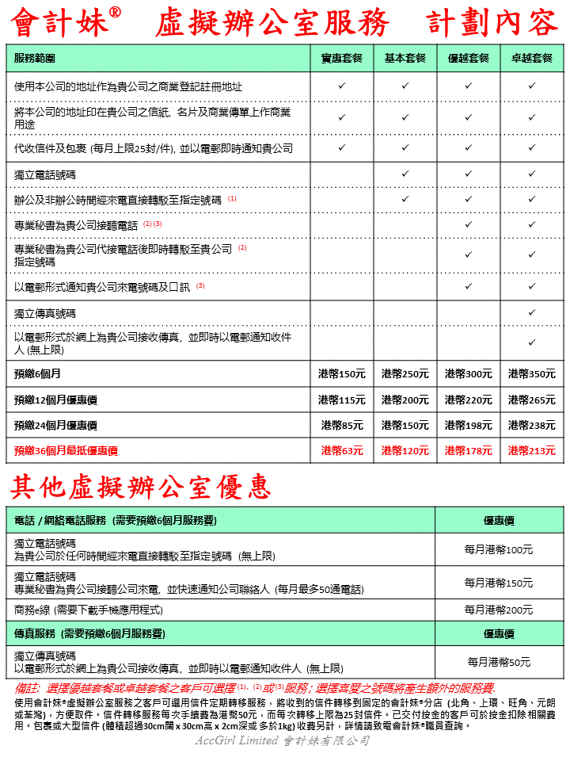

**Appendix A: Service Plan Information**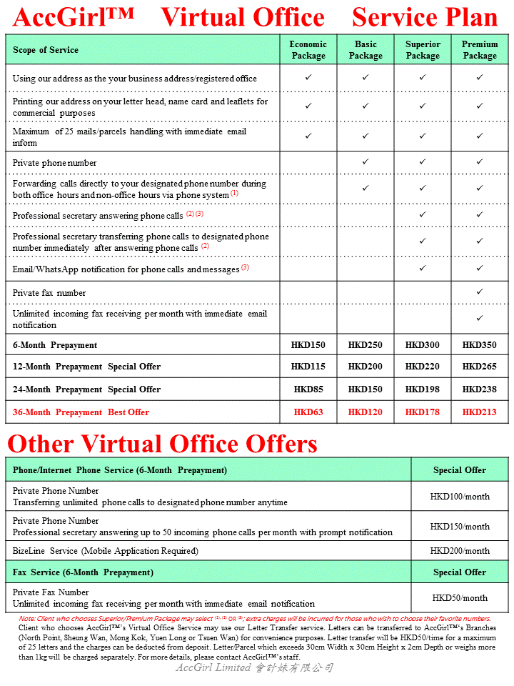

**附件二: 公司備存重要控制人登記冊指引**

**Appendix B: Guideline on the Keeping of Significant Controllers Registers by Companies**

|  |
| --- |
| **對公司有重大控制權的條件　Conditions for Significant Control Over The Company** |
| 某人如符合下述五個條件之中的一個或以上條件，即對公司有重大控制權 —  A person has significant control over a company if one or more of the following 5 conditions are met –   * **該人直接或間接持有公司 25% 以上的已發行股份；或如公司沒有股本，該人直接或間接享有分攤公司 25% 以上資本或分享公司25%以上利潤的權利**   **The person holds, directly or indirectly, more than 25% of the issued shares in the company or, if the company does not have a share capital, the person holds, directly or indirectly, a right to share in more than 25% of the capital or profits of the company**   * **該人直接或間接持有公司 25% 以上的表決權**   **The person holds, directly or indirectly, more than 25% of the voting rights of the company**   * **該人直接或間接持有委任或罷免公司董事局的過半數董事的權利**   **The person holds, directly or indirectly, the right to appoint or remove a majority of the board of directors of the company**   * **該人有權利或實際上對公司發揮或行使重大影響力或控制**   **The person has the right to exercise, or actually exercises, significant influence or control over the company**   * **該人有權利或實際上對某信託或商號的活動發揮或行使重大影響力或控制，而該信託或商號並不是法人，但該信託的受託人或商號的成員 (以其作為信託受託人或商號成員的身分)，就公司而言符合首四個條件之中的任何一個條件**   **The person has the right to exercise, or actually exercises, significant influence or control over the activities of a trust or a firm that is not a legal person, but whose trustees or members satisfy any of the first four conditions (in their capacity as such) in relation to the company** |

|  |
| --- |
| **擔任指定代表的條件　Requirements for Acting as the Designated Representative** |
| 公司須指定最少一名人士為該公司的代表，以提供與該公司的重要控制人登記冊有關的協助予執法人員 。公司的指定代表須由以下任何一類人士擔任 —  A company must designate at least one person as its representative to provide assistance relating to the company’s SCR to a law enforcement officer. A company’s designated representative must be one of the following –   * **該公司的成員、董事或僱員，而且必須是居於香港的自然人**   **A member, director or an employee of the company who is a natural person resident in Hong Kong**   * **《打擊洗錢及恐怖分子資金籌集條例》(第 615 章 (下) 稱“《打擊洗錢條例》”) 所界定的會計專業人士、法律專業人士或信託或公司服務持牌人**   **An accounting professional, a legal professional or a TCSP licensee as defined in the Anti-Money Laundering and**  **Counter-Terrorist Financing Ordinance, Cap. 615 (“AMLO”)** |

以上基本指引只供參考，如欲了解更多有關公司備存重要控制人登記冊的詳情，請點擊以下網址以下載由公司註冊處發出的公司備存重要控制人登記冊指引 <https://www.cr.gov.hk/tc/publications/docs/Guidelines_scr_c.pdf> ，或瀏覽公司註冊處網站<https://www.cr.gov.hk/tc/publications/guidelines_02.htm>

The above basic guidelines are for reference only. For more information on keeping of Significant Controllers Registers by companies, please click on the following website to download the Guideline on the Keeping of Significant Controllers Registers by Companies issued by the Companies Registry: <https://www.cr.gov.hk/en/publications/docs/Guidelines_scr_e.pdf> , or visit the Companies Registry website at <https://www.cr.gov.hk/en/publications/guidelines_02.htm>